CONESTOGA COLLEGE INSTITUTE OF TECHNOLOGY & ADVANCED LEARNING



Wireless Network Infrastructure

Project Report

**Realtime GSM+GPS+GPRS Tracking of Package using Arduino**

Submitted by:

Alish Modi (7778996)

Harmeet Singh (8013575)

Navtej Singh (8011405)

**Abstract**

The project will serve as a better option for secure our packet by providing tracking a location of the product by using an Arduino device attached with GPS device and customer can operate Individual application for measure the Real-Time location of the package. In this Arduino based project, we are trying to improve the security of the valuable packages which has been ordered by customers. I can be used by any online shopping companies.

**Declaration**

We hereby declare that our group i.e. Group 7 from Wireless Network Infrastructure course have completed our project on Real-Time GSM+GPS+GPRS of Package using Arduino at Conestoga college from January 15, 2018 to April 25, 2018 under the guidance of our professors Mr. Stephan Sorin and Jonathan Doll and Zafar Taha. We thank them for their motivation and support and we worked with full dedication during the time allotted.

Thanking in anticipation.

**Acknowledgement**

There have been a lot of effort involved in this project. However, it would not have been possible without the kind support and help of our professors Mr. Sorin and Mr. J Doll and Mr. Z Taha. I would like to extend my sincere thanks to all of them.

I am highly indebted to the professors for their guidance and constant supervision as well as for providing necessary information regarding the project and also their support in completing the project.

**Index**

**1.** Introduction

**2.** Overview of the Components Used

**3.** Block Diagram

**4.** Pin Diagram of Arduino UNO

**5.** Pin Diagram of SIM808

**6.** Various Parts and their description

**7.** Mobile Application based on Android Studio

**8.** Working of the Project

**9.** Applications

**10.** Conclusion

**11.** Bibliography

1. **Introduction**

Inmodern world, online shopping is very popular. And USA and CANADA had a lot of heterogeneous systems through online orders up to the Shipment tracking and receive date from their online E-commerce Website. But it is not accurate and because of that, sometime customer’s valuable product was stolen or lost in the way of the delivery and even some time wrong product delivers to the customers.

So, for avoid that kind of problems, we want to track our item side by side because customers are spending a bunch of money on it. And for that, we want to track our package and want to get **track** status, delivery updates by email or by using an application in our mobile. And delivery confirmation for your **parcels**, or any parcel with a **tracking** number.

Here we are going to make a project which could aid customers to get their real time update regarding their product i.e. like proper location of the product by using GPS. This device is deliver which the package and it is attached, and it is connected with GSM SIM-card which will provide feedback information, when customer sends unique code by using allocated application to Access that device.

We are providing a customer with an easy-to-use outline of your parcel tracking and regular updates - simple and suitable. And it is simply used anytime, anywhere with Mobile application.

**2. Overview of the components used in the Project**

* Arduino UNO
* Sim 808
* Arduino USB Cable
* Sim Card
* Battery Power Adapter
* Mobile (for android application)

**3. Block Diagram**

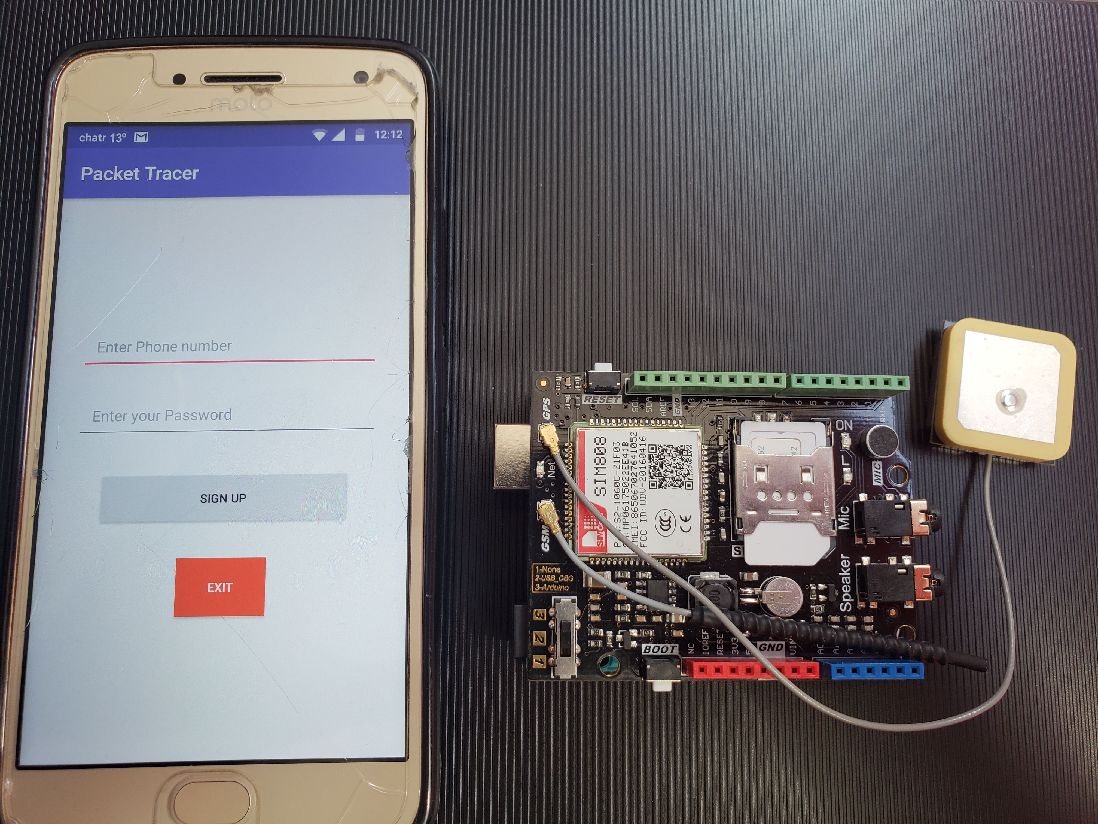

**4. Pin diagram of Arduino UNO**

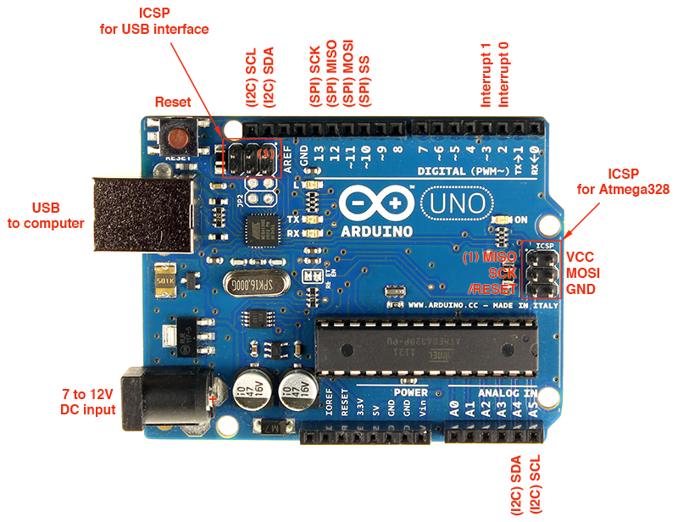

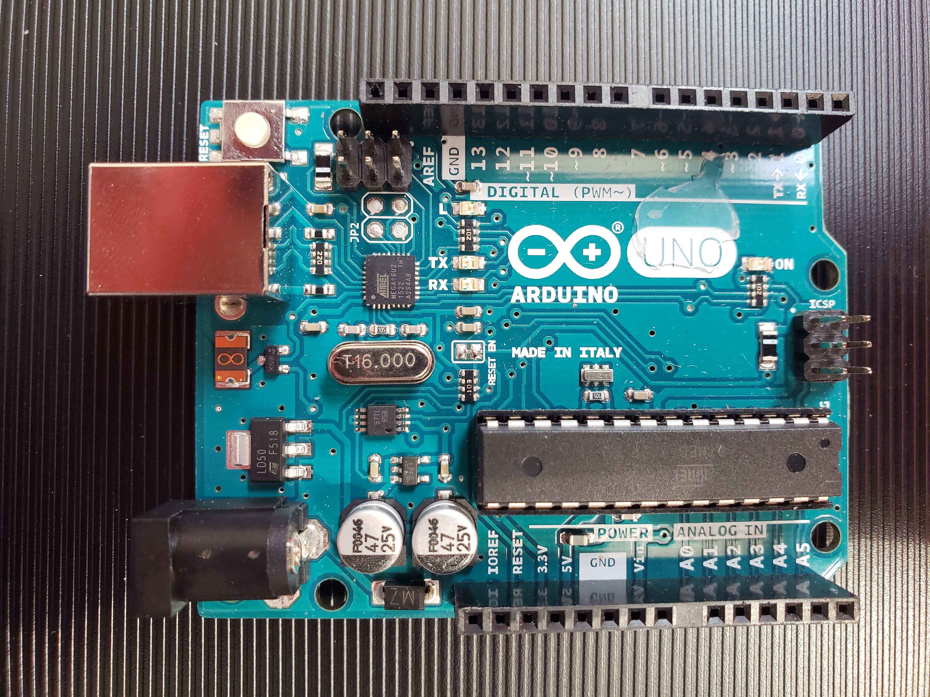

‘

**5. Pin Diagram of Sim 808**

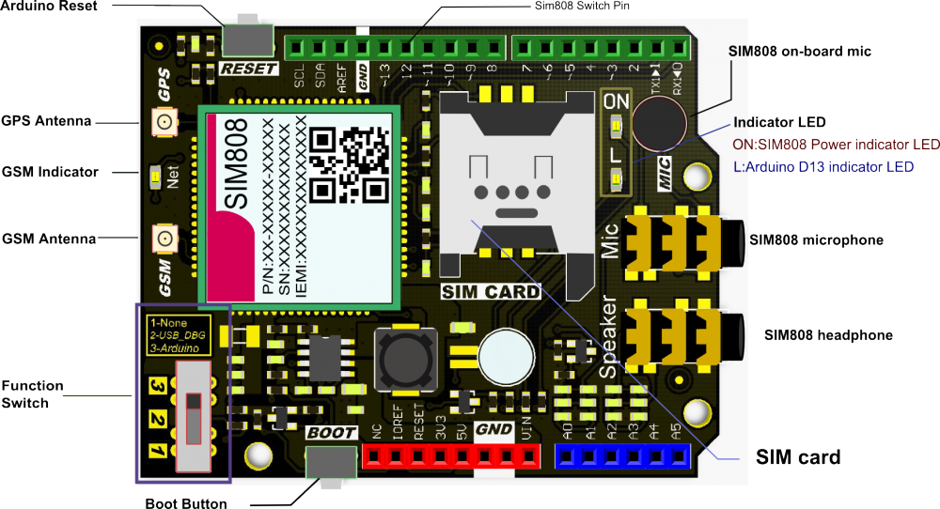

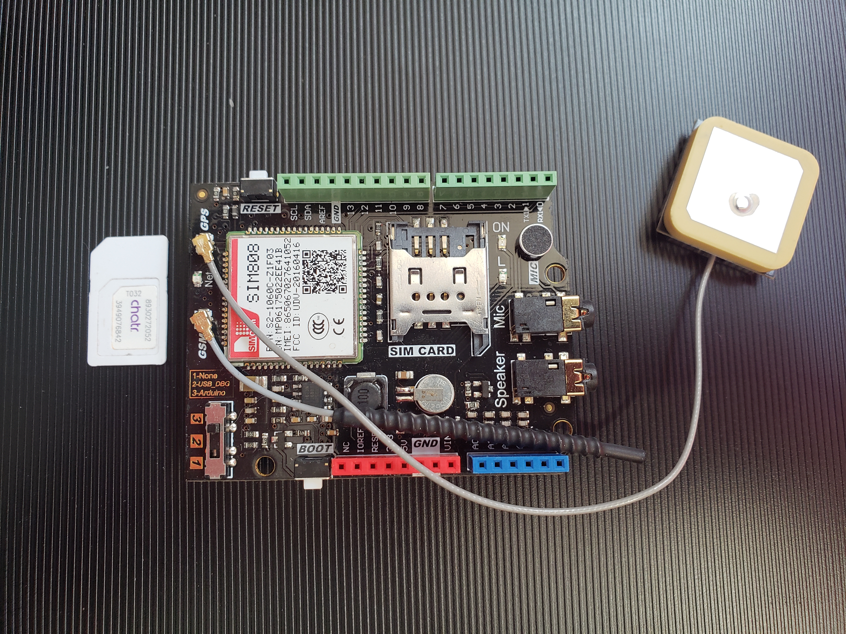

**6. Various Parts and their description**

**6.1 Arduino UNO**

The Arduino UNO is a widely used open-source microcontroller board which is based on the ATmega328P microcontroller and it was developed by Arduino.cc. This Arduino board is basically equipped with the sets of digital as well as analog input/output pins that may be interfaced to different expansion boards and various others circuits. In this, there are 14 different digital pins and 6 analog pins and it is also programmable with the Arduino IDE which means Integrated Development Environment and it is link via a type B USB cable. The voltage between 7 and 20 volts. It is similar to the Arduino Nano and Leonardo. Moreover, UNO means one is Italian and it was chosen to the mark the release of Arduino Software and it was series of USB Arduino boards and the reference model for the Arduino platform. It comes with preprogrammed with a bootloader that allows to upload new code to it without the need of an external hardware programmer.

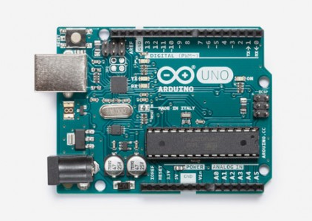

**6.2 Sim 808**

This GPRS GSM GPS Shield based on the SIM808 GSM GPRS GPS all-in-one cellular phone module. You can add location-tracking, voice, text, SMS and data to your project. This shield fits right over your Arduino. it is easy to use. This shield fits right over your Arduino or compatible. At the heart is a powerful GSM cellular module (we use the latest SIM808) with integrated GPS.

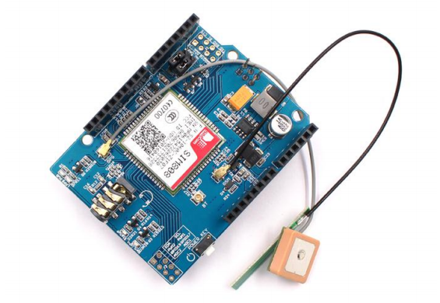

**Features:**

• Quad-band 850/900/1800/1900MHz - connect onto any global GSM network with any 2G SIM (in the USA, T-Mobile is suggested)

• Fully-integrated GPS

• Make and receive voice calls using a headset or an external 32Ω speaker + electret microphone

• Send and receive SMS message

• AT command interface with "auto baud" detection

• Send and receive GPRS data (TCP/IP, HTTP, etc.)

• GPS L1 C/A code

• 22 tracking /66 acquisition channels

• Tracking: -165 dBm

• Cold starts: -148 dBm

• Time-To-First-Fix：Cold starts-32s (typ.) ，Hot starts-1s (typ.) ，Warm starts-5s (typ.)

• Accuracy: approx. 2.5 meters

• Dimensions: 68mm*53mm*23mm

**6.3 GPS Antenna**

The Global Positioning System (GPS) is a location system based on a constellation of about 24 satellites orbiting the earth at altitudes of approximately 11,000 miles. GPS was developed by the United States Department of Defense (DOD), for its tremendous application as a military locating utility. The DOD's investment in GPS is immense. Billions and billions of dollars have been invested in creating this technology for military uses. However, over the past several years, GPS has proven to be a useful tool in non-military mapping applications as well.

GPS satellites are orbited high enough to avoid the problems associated with land-based systems, yet can provide accurate positioning 24 hours a day, anywhere in the world. Uncorrected positions determined from GPS satellite signals produce accuracies in the range of 50 to 100 meters. When using a technique called differential correction, users can get positions accurate to within 5 meters or less.

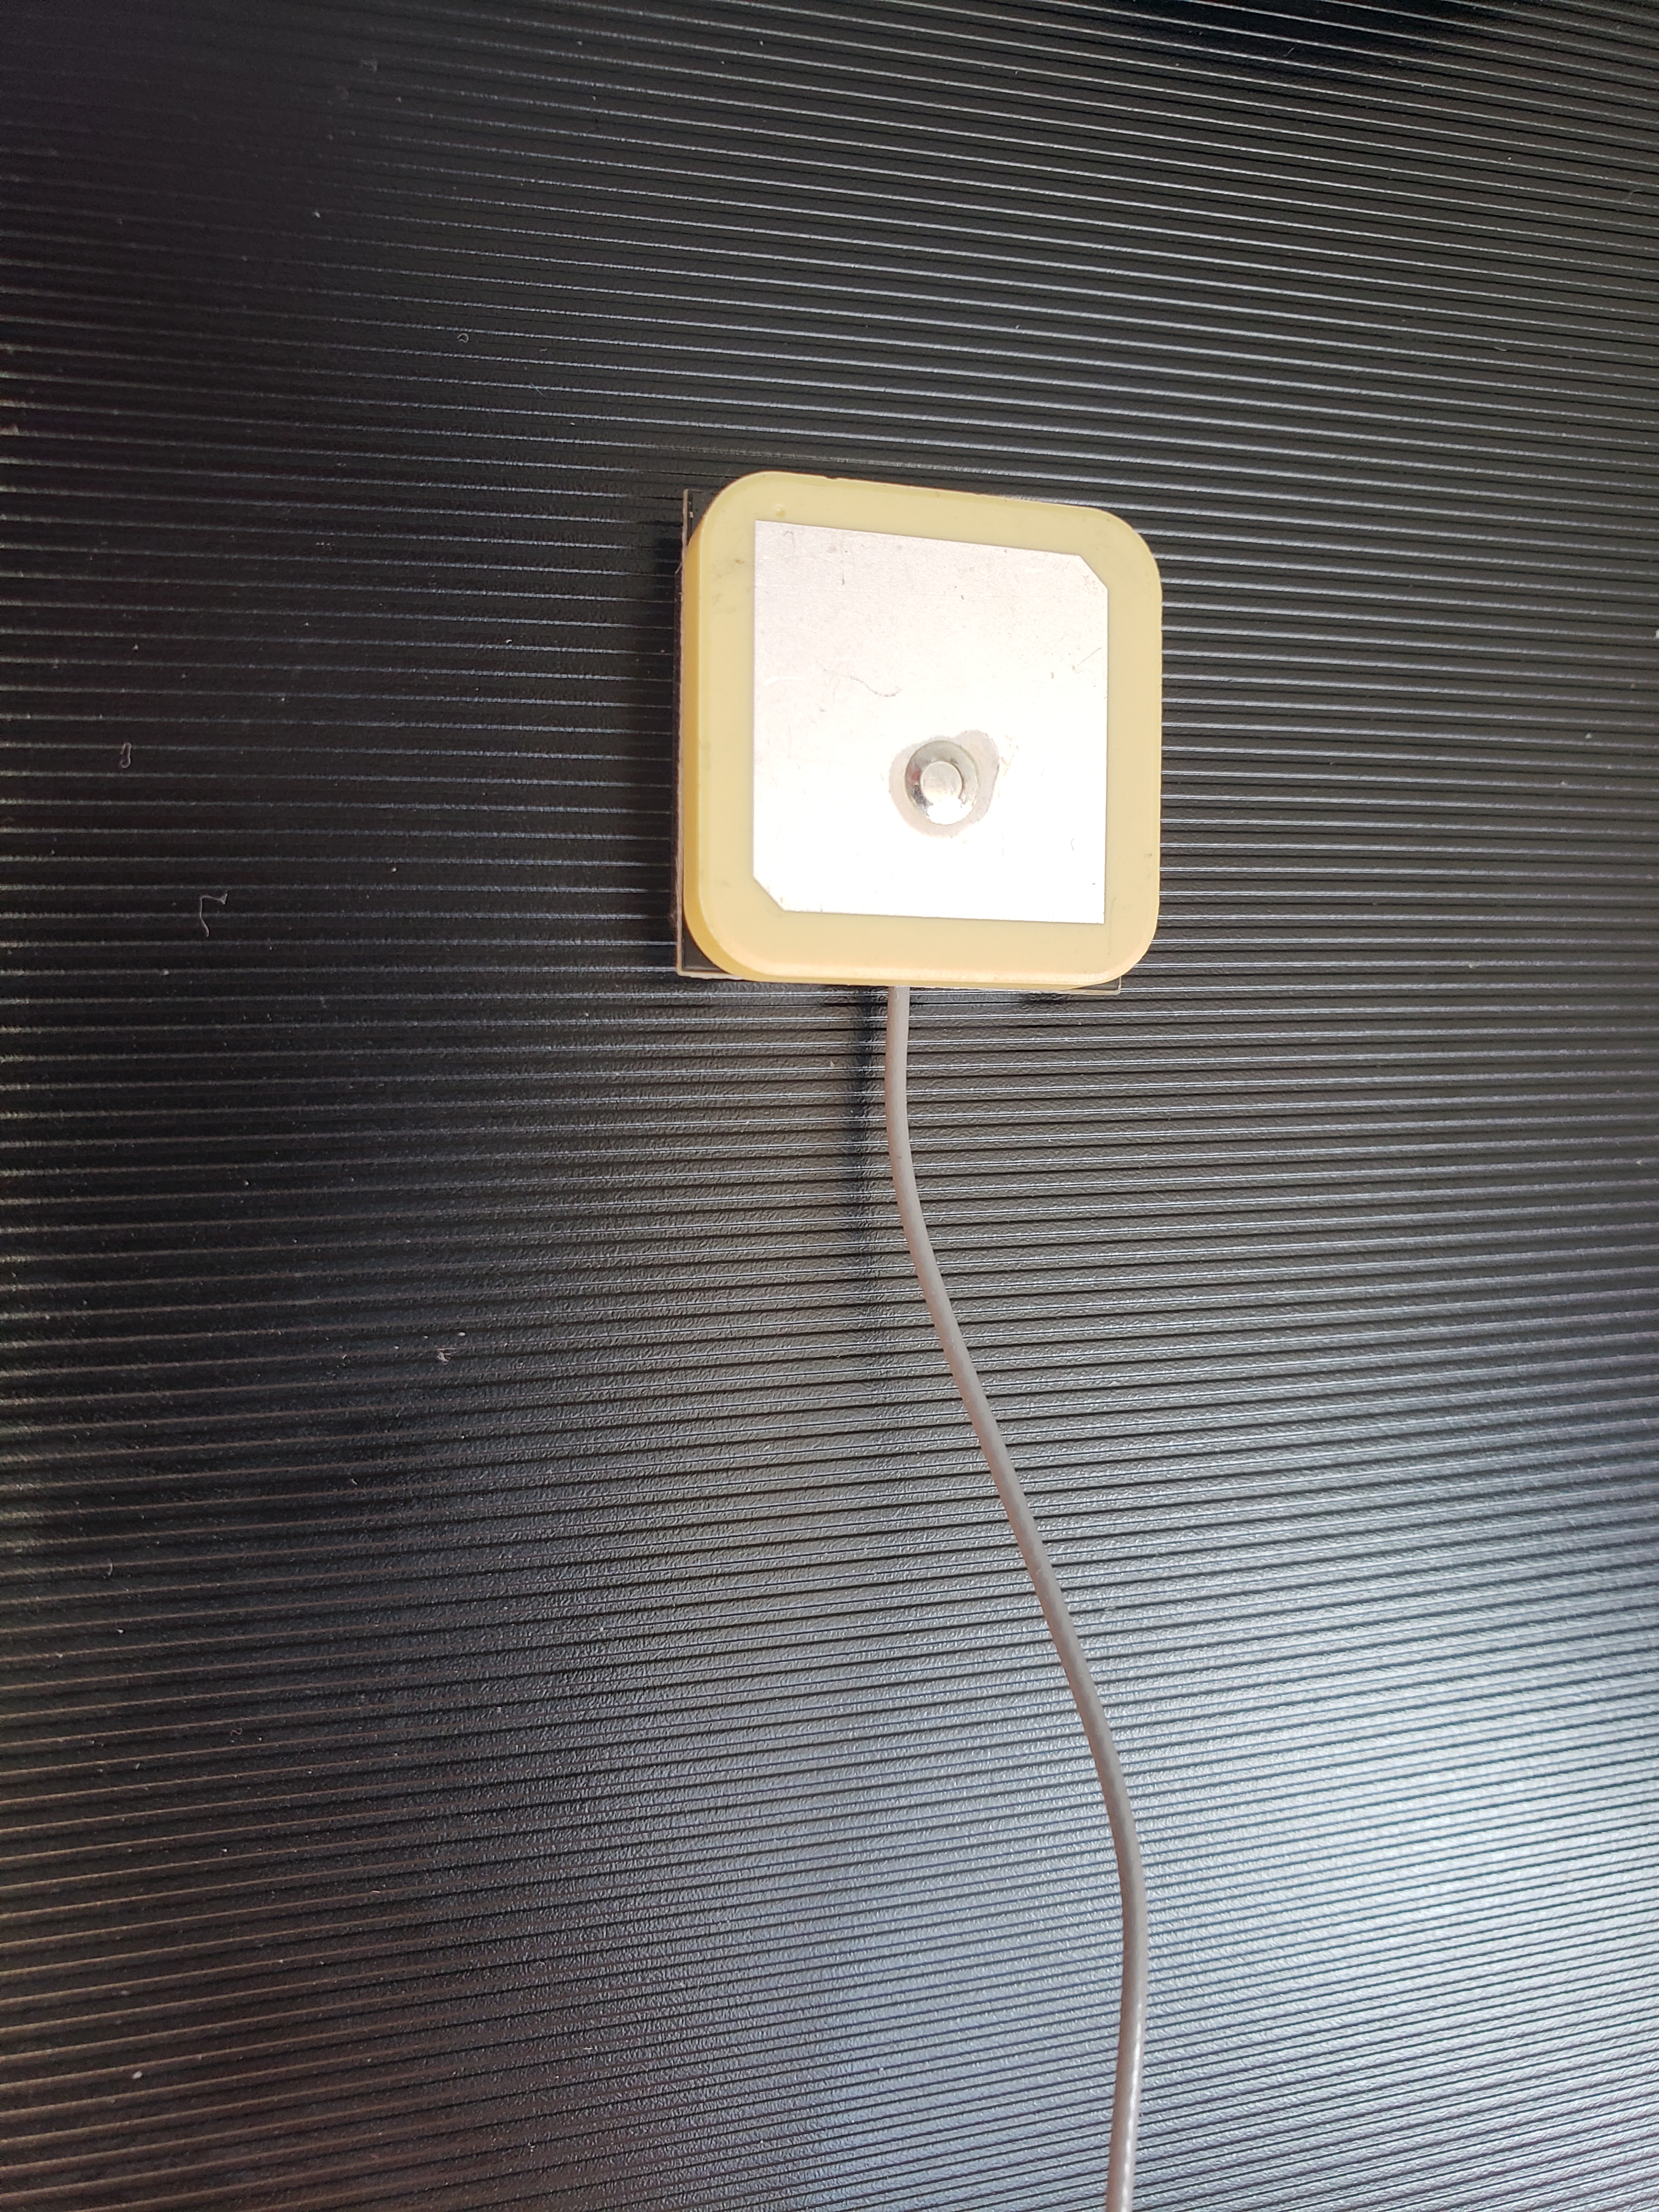

**GSM Antenna:**

Global System for Mobile (GSM) communication systems are fast becoming the standard in mobile phones everywhere. The GSM system allows users to talk virtually anywhere in the world. It’s essentially a global roaming service that’s based on satellite communications, and it offers extraordinary flexibility and freedom for mobile phone users who have embraced this wireless technology. Like any wireless technology, however, GSM communications are dependent on antennas. That means that GSM services, and later generations of the technology like EDGE, UMTS, and HSDPA, are in constant need of custom antenna designers to help them keep up with customer demand and to introduce new innovations to the marketplace.

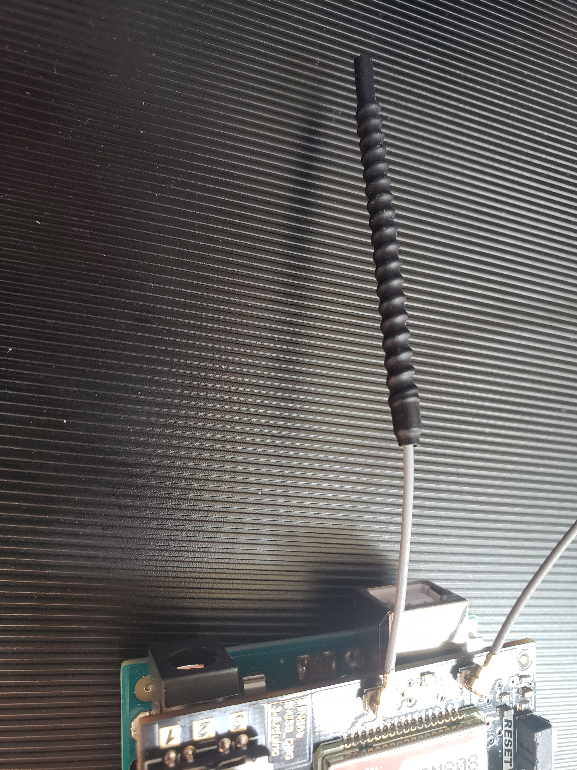

**Coding for Arduino program:**

#include <DFRobot_sim808.h>

#include <SoftwareSerial.h>

//Mobile phone number, need to change

#define PHONE_NUMBER "+15195721264"

#define MESSAGE_LENGTH 160

char message[MESSAGE_LENGTH];

int messageIndex = 0;

char phone[16];

char datetime[24];

//The content of messages sent

//#define MESSAGE "http://maps.google.com/maps?q=%s,%s"

DFRobot_SIM808 sim808(&Serial);

char POSITION_MESSAGE[300];

char lat[12];

char lon[12];

boolean getGPS();

boolean readSMS();

boolean readLocation = false;

void setup() {

//mySerial.begin(9600);

Serial.begin(9600);

//******** Initialize sim808 module *************

while(!sim808.init()) {

delay(1000);

Serial.print("Sim808 init error\r\n");

}

Serial.println("Sim808 init success");

//Serial.println("Start to send message ...");

//******** define phone number and text **********

//sim808.sendSMS(PHONE_NUMBER,MESSAGE);

}

void loop()

{

boolean smsRead = readSMS();

//boolean isLocationAvailable = false;

if(smsRead)

{

while(!getGPS())

{

}

delay(000);

sim808.sendSMS(PHONE_NUMBER,POSITION_MESSAGE);

delay(10000);

readLocation = false;

}

sim808.detachGPS();

}

boolean readSMS()

{

boolean smsAvailable = false;

messageIndex = sim808.isSMSunread();

Serial.print("messageIndex: ");

Serial.println(messageIndex);

//*********** At least, there is one UNREAD SMS ***********

if (messageIndex > 0) {

sim808.readSMS(messageIndex, message, MESSAGE_LENGTH, phone, datetime);

//***********In order not to full SIM Memory, is better to delete it**********

sim808.deleteSMS(messageIndex);

Serial.print("From number: ");

Serial.println(phone);

Serial.print("Datetime: ");

Serial.println(datetime);

Serial.print("Recieved Message: ");

Serial.println(message);

smsAvailable = true;

}

return smsAvailable;

}

boolean getGPS()

{

while(!sim808.attachGPS())

{

Serial.println("Open the GPS power failure");

delay(1000);

}

delay(3000);

Serial.println("Open the GPS power success");

while(!sim808.getGPS())

{

}

//delay(3000);

Serial.print(sim808.GPSdata.year);

Serial.print("/");

Serial.print(sim808.GPSdata.month);

Serial.print("/");

Serial.print(sim808.GPSdata.day);

Serial.print(" ");

Serial.print(sim808.GPSdata.hour);

Serial.print(":");

Serial.print(sim808.GPSdata.minute);

Serial.print(":");

Serial.print(sim808.GPSdata.second);

Serial.print(":");

Serial.println(sim808.GPSdata.centisecond);

Serial.print("latitude :");

Serial.println(sim808.GPSdata.lat);

Serial.print("longitude :");

Serial.println(sim808.GPSdata.lon);

Serial.print("speed_kph :");

Serial.println(sim808.GPSdata.speed_kph);

Serial.print("heading :");

Serial.println(sim808.GPSdata.heading);

Serial.println();

float la = sim808.GPSdata.lat;

float lo = sim808.GPSdata.lon;

float ws = sim808.GPSdata.speed_kph;

dtostrf(la, 4, 6, lat); //put float value of la into char array of lat. 4 = number of digits before decimal sign. 6 = number of digits after the decimal sign.

dtostrf(lo, 4, 6, lon); //put float value of lo into char array of lon

sprintf(POSITION_MESSAGE, "http://maps.google.com/maps?q=%s,%s", lat, lon);

Serial.println(POSITION_MESSAGE);

delay(3000);

readLocation = true;

//sim808.sendSMS(PHONE_NUMBER,POSITION_MESSAGE);

return readLocation;

}

**Coding for Android Application on Android Studio**

**package** com.project.packettracer.Call;  
  
**import** android.Manifest;  
**import** android.annotation.SuppressLint;  
  
**import** android.content.Intent;  
**import** android.content.pm.PackageManager;  
**import** android.net.Uri;  
**import** android.support.v4.app.ActivityCompat;  
**import** android.support.v4.content.ContextCompat;  
**import** android.support.v7.app.AppCompatActivity;  
**import** android.os.Bundle;  
**import** android.text.TextUtils;  
**import** android.util.Log;  
**import** android.view.View;  
**import** android.widget.Button;  
**import** android.widget.EditText;  
**import** android.widget.Toast;  
  
  
**public class** MainActivity **extends** AppCompatActivity **implements** ActivityCompat.OnRequestPermissionsResultCallback {  
  
 **static boolean** *PermissionGranted*;  
 **private static final int *REQUEST_CALL*** = 10;  
 **private static** String[] *PERMISSIONS_CALL* = { Manifest.permission.***READ_PHONE_STATE***,  
 Manifest.permission.***CALL_PHONE***, Manifest.permission.***SEND_SMS***, Manifest.permission.***READ_SMS*** };  
  
 Button **btnCall**, **btnExit**;  
 EditText **etCallNumber**;  
 EditText **etPassword**;  
  
 @Override  
 **protected void** onCreate(Bundle savedInstanceState)  
 {  
 *PermissionGranted* = **false**;  
 **super**.onCreate(savedInstanceState);  
 setContentView(R.layout.*activity_main*);  
  
 SmsReceiver sr = **new** SmsReceiver();  
  
  
  
 sr.*bindListener*(**new** SmsListener() {  
 @Override  
 **public void** messageReceived(String messageText) {  
 Log.*e*(**"Message"**,messageText);  
 *//if(SmsReceiver.senderPhoneNo.equalsIgnoreCase("519-781-1075"))* Toast.*makeText*(MainActivity.**this**,messageText.toString(), Toast.***LENGTH_SHORT***).show();  
  
 Uri gmmIntentUri = Uri.*parse*(**"geo:0,0?q=37.7749,-122.4192(Your Packet)"**);  
 Intent mapIntent = **new** Intent(Intent.***ACTION_VIEW***, gmmIntentUri);  
 mapIntent.setPackage(**"com.google.android.apps.maps"**);  
 startActivity(mapIntent);  
 }  
 });  
  
 **btnCall** = findViewById(R.id.*btn_dial*);  
 **btnExit** = findViewById(R.id.*btn_exit*);  
 **etCallNumber** = (EditText) findViewById(R.id.*et_phone_no*);  
 **final** EditText etPassword = (EditText) findViewById(R.id.*et_password*);  
  
 **btnCall**.setOnClickListener(**new** View.OnClickListener()  
 {  
 @SuppressLint(**"MissingPermission"**)  
 @Override  
 **public void** onClick(View v)  
 {  
 String phoneNo = **etCallNumber**.getText().toString();  
 **if** (*PermissionGranted*)  
 {  
 **if** (!TextUtils.*isEmpty*(phoneNo))  
 {  
 String dial = **"tel:"** + phoneNo;  
 startActivity(**new** Intent(Intent.***ACTION_CALL***, Uri.*parse*(dial)));  
 }  
 **else** {  
 Toast.*makeText*(MainActivity.**this**, **"Enter a phone number"**, Toast.***LENGTH_SHORT***).show();  
 }  
 }  
 **else** {  
 Toast.*makeText*(MainActivity.**this**, **"Go to Settings to set your Permissions !"**, Toast.***LENGTH_SHORT***).show();  
 }  
 }  
 });  
  
 **btnExit**.setOnClickListener(**new** View.OnClickListener() {  
 @Override  
 **public void** onClick(View v) {  
 finish();  
 System.*exit*(0);  
 }  
 });  
  
 }  
  
 @Override  
 **protected void** onStart() {  
 **super**.onStart();  
 requestPermissions(*PERMISSIONS_CALL*,R.string.*msg_permission*,***REQUEST_CALL***);  
 }  
  
 **private void** requestPermissions(String[] permissionsCall, **int** msg_permission, **int** requestCode)  
 {  
*// mErrorString.put(requestCode, msg_permission);* **int** permissionCheck = PackageManager.***PERMISSION_GRANTED***;  
 **boolean** showRequestPermissions = **false**;  
  
  
 **for**(String permission: permissionsCall) {  
 permissionCheck = permissionCheck + ContextCompat.*checkSelfPermission*(**this**, permission);  
 showRequestPermissions = showRequestPermissions || ActivityCompat.*shouldShowRequestPermissionRationale*(**this**, permission);  
 }  
  
 **if** (permissionCheck!=PackageManager.***PERMISSION_GRANTED***)  
 {  
 **if**(showRequestPermissions) {  
 ActivityCompat.*requestPermissions*(MainActivity.**this**, permissionsCall, requestCode);  
 } **else** {  
 ActivityCompat.*requestPermissions*(**this**, permissionsCall, requestCode);  
 }  
 }  
 **else** {  
 onPermissionsGranted(requestCode);  
 }  
 }  
  
 **public void** onPermissionsGranted(**int** requestCode) {  
 *//Do anything when permisson granted* **switch**(requestCode)  
 {  
 **case *REQUEST_CALL***:  
 *PermissionGranted* = **true**;  
 Toast.*makeText*(getApplicationContext(), **"Permission granted"**, Toast.***LENGTH_SHORT***).show();  
 **break**;  
 }  
 }  
  
}

**Working of the Project**

Basically, the project is about the tracking the product or any package, which folks order some products through online markets. For that purpose, we have to develop some security for that products. There have been one way to track packages or tracking system methods in which if a customer can find about the Real-time location of their product by using this project or attach it with the packages and after installing our android application which is “Packet Tracer” on their smart phones and by using that application they need to message on number which used into the device and device activated, and gives a feedback SMS as real-time location of the product. And our Application open this link directly into the google-MAP which get information about product’s ON-TIME location and distance between you and your product (Packet Tracer Device). i.e. how far is that from their home and how long it takes to reach.

**Challenges faced**

In the starting weeks of the project we tried doing the program for Arduino UNO with the SIM808 and GPS Antenna and GSM Antenna. We have to connect our module with our phone and send the “HELLO WORLD” message from Arduino Module using SIM808.

After getting success we have to convert this message into GPS location format (“http format”) so we use the GPS location library program for sending location. And we face difficulty into merging two programs for “message sending” and “GPS-Location tracking” and finally we get the success in create the “location tracer” and send it successfully.

We use low power GPS Antenna and GSM Antenna which cannot perform well into the close location so we face difficultly into getting our longitude and latitude values and we find out how to solve it and how it works on open area.

Then we have developed Android Application by using the “Android Studio” by learning and watching different sites. And find a way to connect it with our device using “GSM call-receive” library and generate call from mobile and receive location through our Application.

**Advantages:**

* We can find the real time location of the packages by using this project.
* It secures online orders.
* It’s flexible and versatile
* Its easy to implement this device and android application
* Fewer missing package request

**Conclusion**

As a conclusion this project has successfully reached the aimed and objectives that were set at the start of the project. There were many problems faced in this project like programming in the Arduino and programming in the android application. Arduino was used at the starting but as the size of the program was large and was exceeding the memory limit of the Arduino, and after connecting it with SIM808 we have face some problems in getting GPS-location every time. Because we use low power GPS Antenna and GSM Antenna which need open space area. Moreover, there was difficult it is difficult to connect device with the Application. But we get success in it.

This project can be used for various security purposes and is of low cost and is much effective.

**Bibliography, References: -**

[**https://www.dfrobot.com/wiki/index.php/SIM808_GPS/GPRS/GSM_Shield_SKU:_TEL0097**](https://www.dfrobot.com/wiki/index.php/SIM808_GPS/GPRS/GSM_Shield_SKU:_TEL0097)

[**https://www.dfrobot.com/product-1469.html?gclid=Cj0KCQjw5fDWBRDaARIsAA5uWThPPoQSVsXh7bdUTkP87ilsDfT8BCtG6ZuMe9xu5fqHtd5q5__5-v0aAkCZEALw_wcB**](https://www.dfrobot.com/product-1469.html?gclid=Cj0KCQjw5fDWBRDaARIsAA5uWThPPoQSVsXh7bdUTkP87ilsDfT8BCtG6ZuMe9xu5fqHtd5q5__5-v0aAkCZEALw_wcB)

[**https://www.youtube.com/watch?v=mvfTxRGTHWc&t=568s**](https://www.youtube.com/watch?v=mvfTxRGTHWc&t=568s)

[**https://create.arduino.cc/editor/ALISH/52f2bdb1-4fa2-4ee3-b5be-39893c597a34**](https://create.arduino.cc/editor/ALISH/52f2bdb1-4fa2-4ee3-b5be-39893c597a34)

[**https://www.elecrow.com/wiki/index.php?title=SIM808_GPRS/GSM%2BGPS_Shield_v1.1**](https://www.elecrow.com/wiki/index.php?title=SIM808_GPRS/GSM%2BGPS_Shield_v1.1)

[**https://github.com/DFRobot/DFRobot_SIM808**](https://github.com/DFRobot/DFRobot_SIM808)